AYANTRA

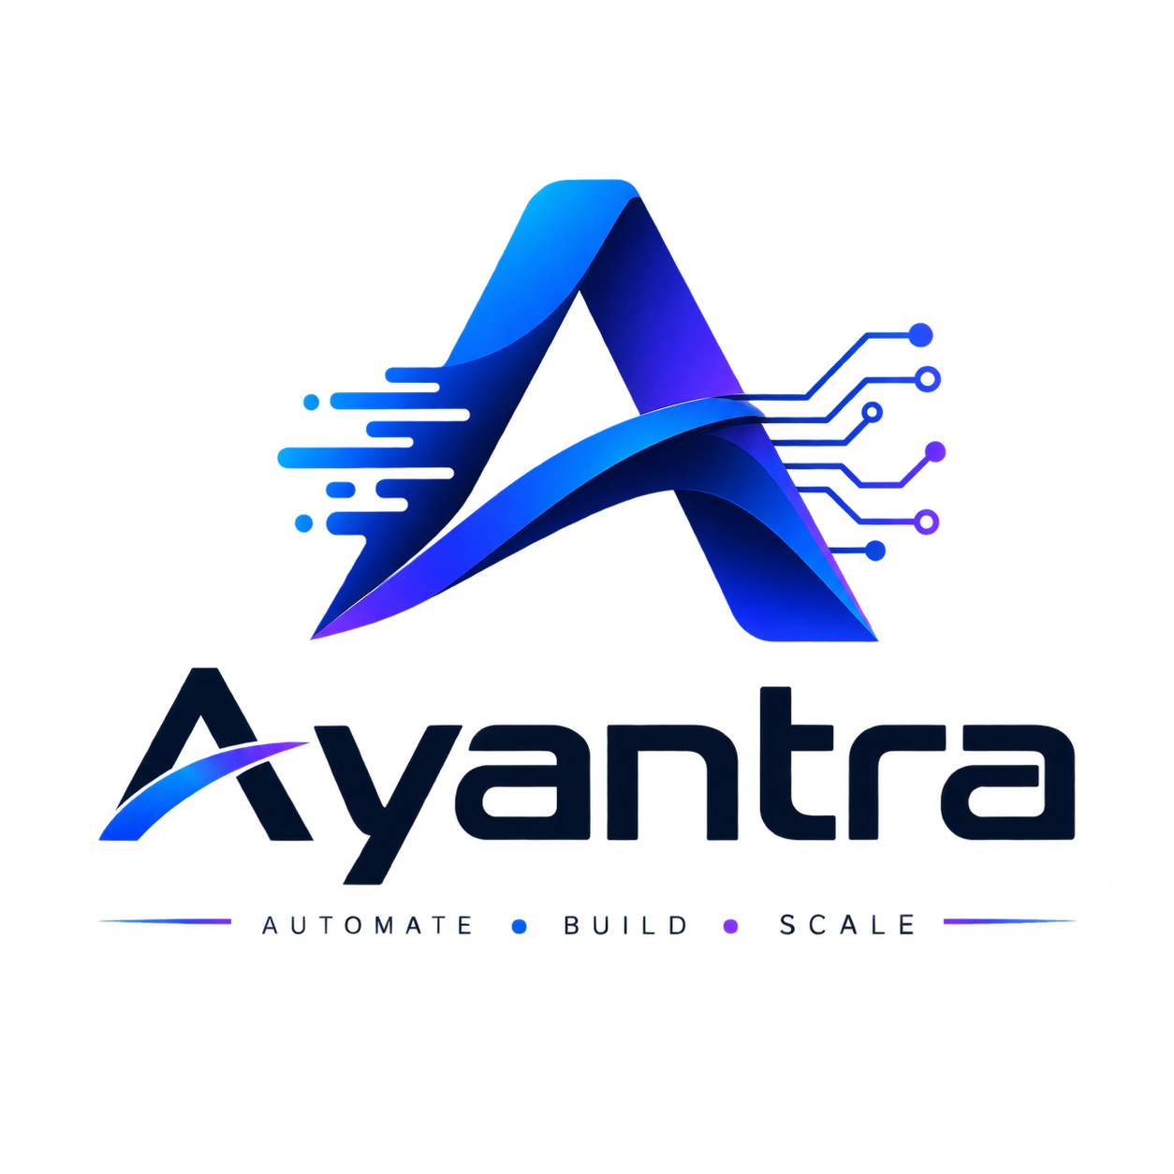
Official Commercial Pricing & Service Engagement Framework

��- 9049013716 | 💌- dev.77anuj77@gmail.com
Document Reference: AY-COM-2026-V1 | Effective Date: August 2026

1. Executive Summary & Value Philosophy

- Outcome-Centric Approach: Ayantra focuses on creating high-converting, professional digital assets tailored to enhance brand authority and acquire customers.
- Predictable Project Budgeting: Fixed packages ensure total transparency, eliminating hourly ambiguity while maintaining standard engineering quality.

2. Core Service Packages

Ayantra Starter (₹7,500)
- Intended Audience: Solo entrepreneurs, freelancers, and small local businesses requiring an immediate digital footprint.
- Deliverables: Single-page responsive landing page (mobile/desktop), contact & WhatsApp call-to-action (CTA), subtle UI animations, foundational on-page SEO, standard deployment.
- Revision Scope: 1 round of design and content adjustments.

Ayantra Growth (₹15,000)
- Intended Audience: Growing businesses and startups focused on direct lead generation and campaign traffic.
- Deliverables: Bespoke UI/UX design, mobile-first responsive development, smooth animations, lead capture form, direct WhatsApp integration, basic SEO structuring, Google Analytics integration, production deployment.
- Revision Scope: 2 to 3 rounds of design and content adjustments.

Ayantra Pro (₹25,000 – ₹35,000+)

- Intended Audience: Established brands and high-growth startups requiring comprehensive, multi-section digital platforms.
- Deliverables: Multi-page architecture, custom animations and interactions, optional dynamic CMS/blog setup, API forms and third-party integrations, search engine optimization, analytics dashboard integration, core web vitals optimization, production deployment.
- Revision Scope: 3 structured rounds of adjustments.

3. Extended Web Solutions Rate Card

Package Name | Target Client Profile | Core Inclusions | Investment Range
Starter Landing Page | Individuals & Small Businesses | 1-page responsive layout, basic animations, CTA setup. | ₹7,500 – ₹9,999
Business Landing Page | Startups & Local Businesses | Premium custom UI, contact form, WhatsApp setup, basic SEO. | ₹12,500 – ₹16,999
Premium Landing Page | Brands & Funded Startups | Custom design, advanced animations, third-party integrations, GA4. | ₹18,500 – ₹29,999
Business Website | SMEs & Corporate Entities | 4–7 custom pages, responsive build, lead forms, SEO, deployment. | ₹25,500 – ₹44,999
Premium Business Site | Established Enterprises | Custom UI/UX, CMS architecture, integrations, performance tuning. | ₹49,500 – ₹81,999+
Custom Web Application | Tech Startups & Platforms | Auth modules, dynamic dashboard, databases, custom REST APIs. | ₹75,000+

4. Direct vs. Third-Party Cost Demarcation

- Ayantra Development Fee: Covers all design, coding, asset structuring, and initial deployment implementation.
- Domain Name Registration: Direct client expense paid annually via the domain registrar (e.g., GoDaddy, Namecheap).
- Hosting & Cloud Infrastructure: Direct client expense billed monthly or annually by the cloud provider (e.g., Vercel, AWS, Hostinger).
- Third-Party Service Subscriptions: API credits, email services, SMS gateways, and CRM licenses are paid directly to the respective providers.
- Post-Launch Maintenance (Optional): Retainer-based maintenance, regular updates, and bug fixes available at ₹2,000 per month.

5. Revision Policy & Scope Definitions

- Definition of a Revision: Modifications to existing copy, visual layouts, colors, fonts, or component placements within the agreed scope.
- Definition of a New Requirement: Additions of new pages, features, workflows, or integrations not specified in the original agreement.
- Out-of-Scope Billing: Additional revision cycles or scope additions are billed at an hourly rate of ₹1,000 per hour or quoted as a separate add-on module.

6. Commercial Terms & Payment Milestones

Standard Projects (< ₹25,000)
- 50% Advance: Due upon project kickoff and requirement confirmation.
- 50% Final Payment: Prior to live domain launch and repository handover.

Enterprise / Multi-Phase Projects (≥ ₹25,000)
- 40% Advance: Project initiation and UI/UX phase.
- 30% Milestone Payment: Functional staging review.
- 30% Final Payment: Final deployment, testing sign-off, and asset transfer.

